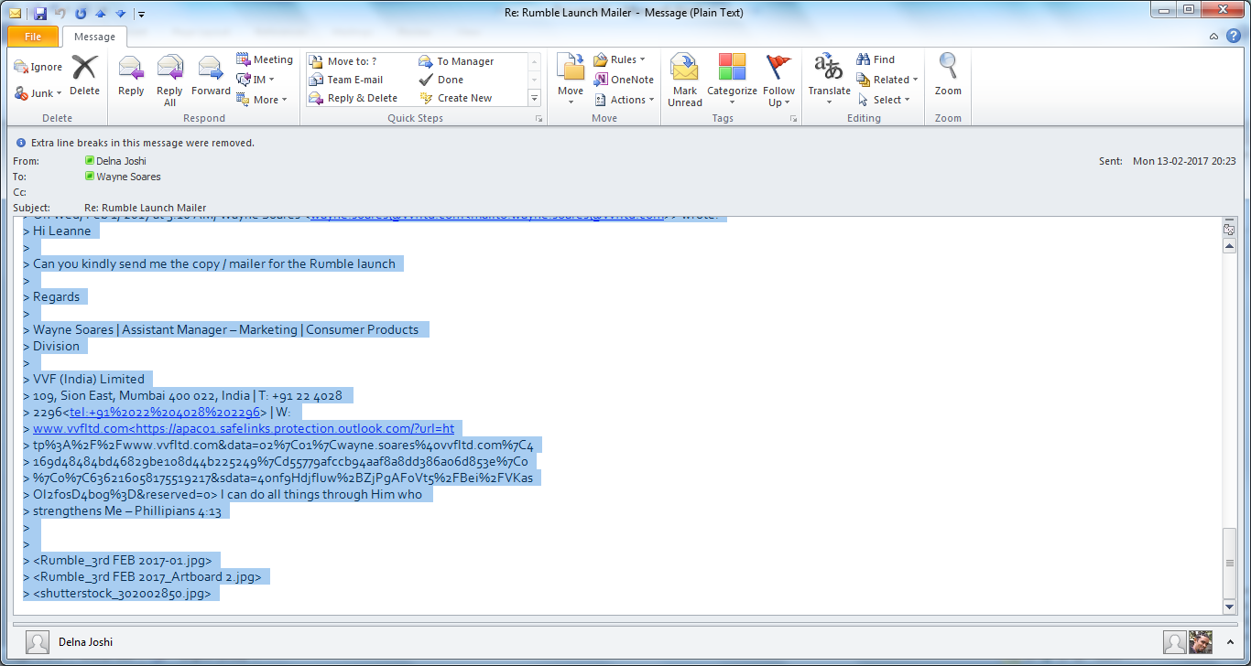

I am not able to go through it this time Wayne. But you go ahead with it, if you have gone through Each of the sections.

> On 10-Feb-2017, at 5:05 PM, Wayne Soares <[wayne.soares@vvfltd.com](mailto:wayne.soares@vvfltd.com)> wrote:

>

> Hi Delna

>

> Can you kindly go through the Rumble as we need to close it. Attached is the Employee Spotlight cover image. Most of these images look alike in terms of theme.

>

> Please go through so we can release the Rumble on Monday.

>

> Regards

>

> Wayne

>

> From: Wayne Soares

> Sent: 05 February 2017 22:36

> To: Delna Joshi

> Subject: Re: Rumble Launch Mailer

>

> Thank you Delna.

> Can you please go through the rumble so we can launch it this week.

> I will be traveling to Chhattisgarh tomorrow morning until Thursday but will try and send it once back in the hotel in the evenings as in the day will be on the field.

>

> The employee spotlight and remarkable rumblings cover photos need changing and will do!

>

> Regards

>

> Wayne

> Get Outlook for iOS<<https://aka.ms/o0ukef>>

>

> ________________________________

> From: Delna Joshi

> Sent: Sunday, February 5, 2017 10:12:49 PM

> To: Wayne Soares

> Subject: Re: Rumble Launch Mailer

>

> I am fine with option 2!

> Looking good !

>

> On 03-Feb-2017, at 5:35 PM, Wayne Soares <[wayne.soares@vvfltd.com<mailto:wayne.soares@vvfltd.com](mailto:wayne.soares@vvfltd.com%3cmailto:wayne.soares@vvfltd.com)>> wrote:

> Hi Delna

>

> These are two rumble mailers which leanne sent copy for.

> The first one has a lot of text which Leanne gave, so I have cut it down in the second one.

> Let me know which one you prefer.

>

> Also please go through the Rumble so we can close it on Monday.

> Let me know if you would like to make any changes. I need to add an

> employee spotlight image which I will tell kunal to do

>

> <http://innercircle.vvfltd.com/index_sample.php?issueid=8&flag=p>

>

> Regards

>

> Wayne

>

> From: Kantilal Patel

> Sent: 03 February 2017 16:19

> To: Wayne Soares

> Subject: RE: Rumble Launch Mailer

>

>

>

> From: Wayne Soares

> Sent: Friday, February 3, 2017 4:07 PM

> To: Kantilal Patel

> Subject: FW: Rumble Launch Mailer

>

>

>

> From: Leanne Engineer [<mailto:leanne.engineer@gmail.com>]

> Sent: 02 February 2017 09:47

> To: Wayne Soares; Kantilal Patel

> Subject: Re: Rumble Launch Mailer

>

> Hi

> Below is the copy and image for the rumble launch mailer. Kanti - do prepare this and share. Thanks!

>

> Image: 568849309

> Rumbling into 2017!

>

> Every year, we learn something new. We learn about our strengths and our weaknesses and also learn about ways in which we can be better. 2016 was one such year for all of us.

> The Rumble team would like to thank all of you for sharing your valuable lessons and stories with us.

>

> Find out how your VVF colleagues in different parts of the world tackled challenges, overcame obstacles and celebrated their victories in this amazing & inspiring issue of the VVF Rumble!

> [http://innercircle.vvfltd.com/<https://apac01.safelinks.protection.out](http://innercircle.vvfltd.com/%3chttps:/apac01.safelinks.protection.out)

> look.com/?url=http%3A%2F%2Finnercircle.vvfltd.com%2F&data=02%7C01%7Cwa

> yne.soares%40vvfltd.com%7C4169d48484bd46829be108d44b225249%7Cd55779afc

> cb94aaf8a8dd386a06d853e%7C0%7C0%7C636216058175519217&sdata=HVQbw8DH2IV

> t7uTUIzPMRVHzkupgFluFQMlcwJDUozg%3D&reserved=0>

>

> On Wed, Feb 1, 2017 at 3:16 AM, Wayne Soares <[wayne.soares@vvfltd.com<mailto:wayne.soares@vvfltd.com](mailto:wayne.soares@vvfltd.com%3cmailto:wayne.soares@vvfltd.com)>> wrote:

> Hi Leanne

>

> Can you kindly send me the copy / mailer for the Rumble launch

>

> Regards

>

> Wayne Soares | Assistant Manager – Marketing | Consumer Products

> Division

>

> VVF (India) Limited

> 109, Sion East, Mumbai 400 022, India | T: +91 22 4028

> 2296<<tel:+91%2022%204028%202296>> | W:

> www.vvfltd.com<https://apac01.safelinks.protection.outlook.com/?url=ht

> tp%3A%2F%2Fwww.vvfltd.com&data=02%7C01%7Cwayne.soares%40vvfltd.com%7C4

> 169d48484bd46829be108d44b225249%7Cd55779afccb94aaf8a8dd386a06d853e%7C0

> %7C0%7C636216058175519217&sdata=40nf9HdjfIuw%2BZjPgAF0Vt5%2FBei%2FVKas

> OI2fosD4bog%3D&reserved=0> I can do all things through Him who

> strengthens Me – Phillipians 4:13

>

>

> <Rumble_3rd FEB 2017-01.jpg>

> <Rumble_3rd FEB 2017_Artboard 2.jpg>

> <shutterstock_302002850.jpg>